**ME338 - THERMALSCIENCES**

**LABORATORY REPORT**

**Experiment#11**

**Cooling in a Copper Pipe**

**Section 05, Group 02**

**Sam Slaten**

**Due: May 7, 2009**

**Spring 2009**

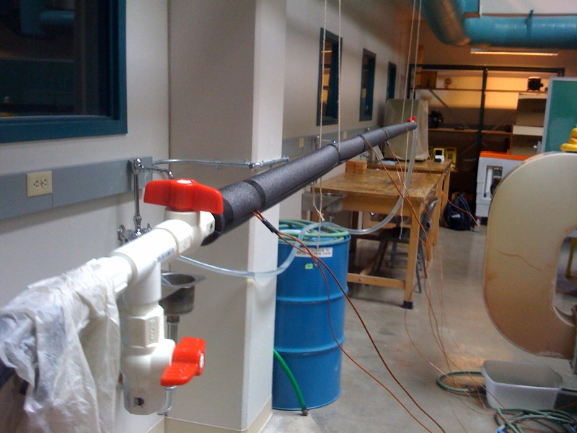

**Department of Mechanical Engineering**

**Colorado State University**

**Table of Contents**

Abstract………………………………………………………………………………………………………………….……..2

Results and Analysis…………………………………………………………………………………………………..…..2

Uncertainty…………………………………………………………………………………………………………………….8

Discussion………………………………………………………………………………………………………………………8

Questions……………………………………………………………………………………………………………………..10

Conclusion……………………………………………………………………………………………………………………11

Appendix 1 Nusselt number heat transfer Calculations…………………………………………….….12

Appendix 2 Heat transfer coefficients Calculations………………………………………………………13

Appendix 3 Thermal resistance of Insulation Calculations………………………………………….…15

Appendix 4 Uncertainty Calculations……………………………………………………………………….…..15

**Abstract:**

This laboratory experiment explores the relationship between different types of insulation, and their effectiveness at insulating a standard household copper pipe. For a bare copper pipe running through an open space with still air there are several methods of heat transfer occurring. The primary form of heat transfer occurs through natural convection, that is that a hotter body in open space will drive a convective heat transfer process. Radiative heat loss also occurs along the length of pipe, and like natural convection, is also driven by the temperature difference of the pipe and the surroundings. Typically a pipe filled with hot water will be at approximately 130°F, in an open space with an ambient temperature at approximately 60°F.

In this experiment three tests were conducted; Case 1: A bare copper pipe filled with hot water. Case 2: A foam insulated copper pipe filled with hot water. And Case 3: A foam insulated copper pipe filled with hot water wrapped with a layer of Mylar® film. The temperature of the hot water filling the pipe, and the ambient air temperature is known and recorded. For each case the temperature loss as a function of time is recorded and the overall heat transfer coefficient will be calculated. The overall heat transfer coefficient can be compared to theoretically calculated values, and to reference information for heat transfer coefficient. The calculated values for the heat transfer coefficient were found to be 62.288±6.551 $\left(\frac{W}{m^{2}°K}\right)$ for Case 1, 32.393±6.551 $\left(\frac{W}{m^{2}°K}\right)$ for Case 2, and 32.287±6.551 $\left(\frac{W}{m^{2}°K}\right)$ for Case 3. The insulated pipe (Case 2) was found to take about 52.17% longer to cool than the Case 1, and Case 3 was found to take about 104.1% longer to cool than Case 1.

**Results and Analysis:**

With the bare copper pipe both convection and radiation play a role in the heat loss along the pipe, with the insulated pipe convection and conduction should be cut to a minimum, however radiation will still be present, in the third procedure the effects of radiation should be minimized due to a Mylar® film wrapping the pipe.

For this experiment a 10’x ¾” copper pipe is suspended in open air with inlet and outlet valves located on both ends. The inlet side is connected to a hot water source with a vinyl hose. The inlet hose will have a discharge valve to allow hot water to be purged from the incoming side. The outlet valve will be connected to a discharge hose so the water can easily be returned to a drain. Eight thermocouples will be placed on the pipe, three measuring the water temperature inside the pipe, three measuring the surface temperature of the pipe, and two measuring the outside temperature of the insulation. The thermocouples are to be placed at 5’ increments starting at the beginning of the pipe. See figure 1 below.

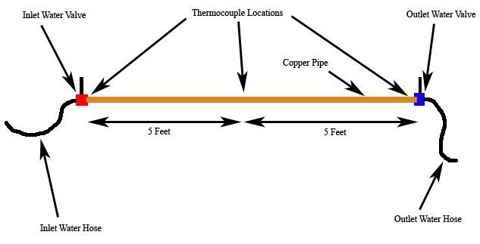

**Figure 1:** Experimental Apparatus used. Apparatus should be freely suspended in air with supports placed to minimize conduction through the support and placed far enough away from objects and air currents to allows only natural convection to occur.

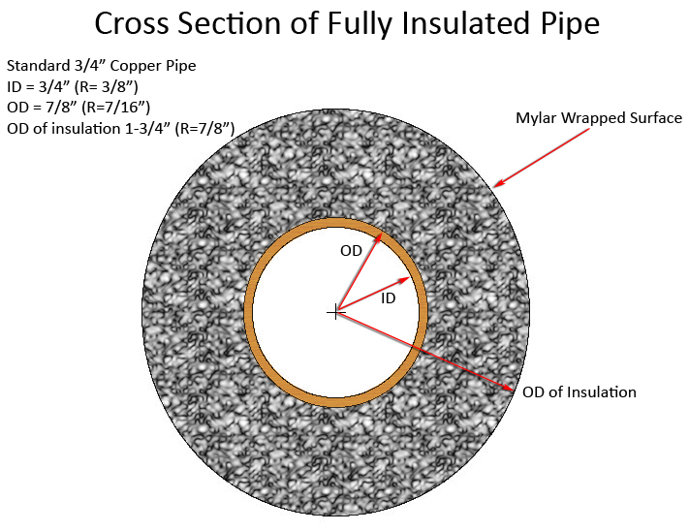

**Figure 2:** Cross Sectional area of experimental apparatus with both foam and Mylar® installed.

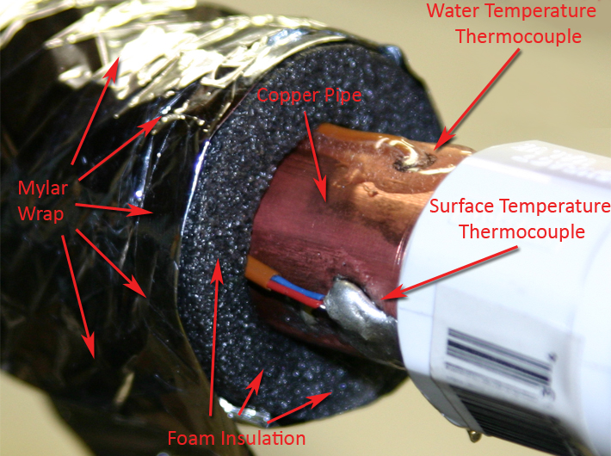

**Figure 3:** Actual experimental apparatus shown. Note plastic inlet valve, water temperature thermocouple epoxied into pipe, and copper pipe surface temperature thermocouple soldered onto pipe.

For a control volume of a copper pipe filled with hot water surrounding this system is an infinite amount of cooler air. As time goes on heat is transferred radially from the control volume to the surroundings until such a time that the hot water-pipe control volume is the same temperature as the surroundings. If the system is maintained with the same mass and allowed to cool, a transient cooling problem presents itself.

The main mechanism of cooling in this situation is free convection. For a horizontal cylinder the average $\overline{Nu}$ number can be calculated by:

$\overline{Nu}={\left\{.6+\frac{.387{Ra}^{1/6}}{{\left[1+{\left({.559}/{Pr}\right)}^{9/16}\right]}^{8/27}}\right\}}^{2}$ (1.3)

Where Ra is the Rayleigh number, and Pr is the constant value of the Prandle number = 0.706.

The Rayleigh number can be defined as:

$Ra=\frac{gβ(T_{s}-T_{film}){L_{c}}^{3}}{υα}$ (1.4)

The heat transfer coefficient can be calculated using:

$\overline{h}=\frac{\overline{Nu}k}{L}$ (1.5)

For the case of the bare copper pipe $\overline{h}$ is calculated to be about 39.6 W/m[1] (from equation 1.5), this is similar to known heat transfer values where = 43 W/m[2].

**Table 1:** From the Calculated data in Appendix 2 three heat transfer coefficients are calculated for each case:

|  |  |  |  |
| --- | --- | --- | --- |
|  | Case 1: | Case 2: | Case 3: |
| Heat Transfer Coefficient $\left(\frac{W}{m^{2}°K}\right)$ ±6.551 | 62.288 | 32.393 | 32.287 |

This heat transfer coefficient calculated for case one is significantly higher, about 30-40% than what is calculated based on convection alone, Case 3 show little difference, yet should be about 30% different than Case 2.

From the temperature difference recorded across the insulation the R value of the insulation can be found and then the thermal conductivity (k) can be found. The experimentally calculated R was found to be about 70[3], and the thermal conductivity was found to be about 0.015 $\left(\frac{W}{m°K}\right)$**.** This is in contrast to the value of k for Urethane foam where k=.026[4]. This means that the calculated value is likely somewhat low, and then the R value is somewhat high, but is still a reasonable figure.

**Table 2:** Time required for water temperature inside the pipe in each insulated case to cool down by 10°C.

|  |  |  |
| --- | --- | --- |
| Bare Copper Pipe: | Insulated Copper Pipe: | Insulated Pipe with Mylar Wrap: |
| 828 sec(13.8 minutes) | 1260 sec(21 minutes) | 1690 sec(28.16 minutes) |

**Table 3:** Percentage Time increase in cooling over bare pipe(case 1). For each case the time required for the water in the pipe to cool by 10°C increases with the increase in insulation. Each case can be compared to the baseline test, and then to the previous test.

|  |  |  |  |
| --- | --- | --- | --- |
|  | Bare Copper Pipe | Insulated Copper Pipe | Insulated Pipe with Mylar Wrap |
| Cooling Time | 828 sec | 1260 sec | 1690 sec |
| Percentage increase in Cooling time: | | 52.17% longer than Bare Copper Pipe | 104.10% longer than Bare Copper Pipe |
| 34.13% longer than Insulated Copper Pipe |

**Table 4:** Temperature drop for 300 seconds (5 minutes) of cooling in each pipe with a starting temperature T≈60°C.

|  |  |  |  |
| --- | --- | --- | --- |
|  | Bare Copper Pipe | Insulated Copper Pipe | Insulated Pipe with Mylar Wrap |
| ΔT (°C) | 4.29 | 2.77 | 2.03 |

**Figure 4:** Cooling trend of water inside the pipe. For the same starting temperature the cooling data can be plotted against time. The red line indicates the bare copper pipe(Case 1), the blue line the insulated pipe(Case 2), and the green line indicates the Mylar wrapped pipe(Case 3).

**Figure 5:** Temperature difference across the conductive surface, used for calculating the thermal conductivity(k) of the material.

**Figure 6:** Inside water temperature vs. insulation surface temperature. This graph shows the surface temperature of the insulation with and without the Mylar, and the corresponding water temperature.

In figure 6 it can been seen that while the outside surface temperature is not greatly affected by the Mylar wrap and remains relatively constant at a few degrees above ambient temperatures, the inside water temperature drops less relative to the water temperature without the Mylar.

**Uncertainty:**

Overall the uncertainty in the convective heat transfer coefficient was found to be 6.551 $\left(\frac{W}{m°K}\right)$. This is reasonable but somewhat high compared to the calculated heat transfer coefficients as it represents about a 10.5% error for Case 1, and about a 20% error for Case 2 and Case 3. Additional less quantifiable uncertainties which can affect the calculations can come from a number of different sources. If any atmospheric conditions vary, including the temperature, pressure, humidity, and most importantly, how stagnant the air surrounding the pipe is, the ability of the surrounding air to transfer heat will change. If air is forced past the pipe, meaning is convection other than natural convection occurs, the heat transfer coefficient can vary greatly. It is important to keep the ambient conditions as consistent as possible during the different experimental cases. Full Uncertainty calculations can be found in Appendix 4.

**Discussion:**

For a bare copper pipe running through an open space with still air there are several methods of heat transfer occurring. The primary form of heat transfer occurs through natural convection, that is that a hotter body in open space will drive a convective heat transfer process. Radiative heat loss also occurs along the length of pipe, and like natural convection, is also driven by the temperature difference of the pipe and the surroundings. Typically a pipe filled with hot water will be at approximately 130°F, in an open space with an ambient temperature at approximately 60°F.

In this experiment three tests were conducted; Case 1: A bare copper pipe filled with hot water, Case 2: A foam insulated copper pipe filled with hot water, and Case 3: A foam insulated copper pipe filled with hot water wrapped with a layer of Mylar® film.

Overall the insulation wrapped with Mylar performed the best. For a temperature drop of 10°C the insulated copper pipe took about 50% longer to cool than the bare pipe. The insulated pipe wrapped with the Mylar took about twice as long(100% longer) to cool than the bare copper pipe.

In table 1 the calculated heat transfer coefficients can be compared to those determined via calculations for convective heat transfer, and for known values of heat transfer. Both calculated and known values for heat transfer should be around 40-46 $\left(\frac{W}{m^{2}°K}\right)$ in contrast to the experimentally calculated 62 $\left(\frac{W}{m^{2}°K}\right)$ for Case 1**.** This is a reasonable difference between the expected and the recorded as the expected value does not take into account radiation as a heat loss. With radiation included, and knowing the difference in cooling times between Case 2 and 3(where radiation is nearly negated), it would be reasonable to expect that the difference is largely due to radiation heat loss. Including radiation will increase the overall heat transfer coefficient. The calculated value of 33 $\left(\frac{W}{m^{2}°K}\right)$ is reasonable to expect for Case 2 as it is about half of the determined value for case one. Since the cooling time for case two is about half that of case one it follows that the heat transfer coefficient is about the same. The calculated value of 32 $\left(\frac{W}{m^{2}°K}\right)$ for the heat transfer coefficient in Case 3 seems to be too high. Knowing that Case 3 took about 35% longer to cool than Case 2 it would be more reasonable to expect this result to be about 21 $\left(\frac{W}{m^{2}°K}\right)$. This may be due to a bad thermocouple reading in the final data series of the outside temperature, or even a change in the ambient conditions such that the data cannot be reasonably compared, i.e. a change in the ambient temperature, or even a degree of forced convection occurring because of forced air heating/cooling.

Of all Data recorded and information plotted Figure 4 is the most valuable in representing the differences between each case. While Table 3 gives a numerical representation of the differences between the cases Figure 4 gives a visual indicator. As can be seen in Figure 4 for the same starting temperature three cooling curves are plotted as a function of time, over a total period of 300 seconds (5 minutes). The uppermost line represents the cooling curve for the insulated Mylar wrapped pipe, this line show that there is less of a temperature drop per unit of time for Case 3. The middle line is the insulated pipe, and the bottom line is the bare copper pipe. This graph gives a good qualitative visual indicator of the temperature drop, with the Mylar wrapped insulated pipe being the best at preventing heat loss.

In calculating the overall heat transfer coefficient in Case 3, it is assumed that radative heat loss is zero and the Mylar has low conductivity. The actually properties of the Mylar insulation used are not known. Mylar is composed of a highly reflective aluminum coating laid down on a cellophane substrate. Highly polished aluminum reflects about 98% of all radiation incident onto its surface[5], this means that aluminum makes an excellent barrier against radiative heat loss. Even though the surface was wrapped with Mylar radiative heat loss occurs in all directions, and even though the ends of the pipe were capped with plastic valves it is reasonable to assume that these valves do little to prevent radiative loss out the ends of the pipes. However this error is likely small as the emission area of the end of the pipe is small compared to the surface area of the whole pipe.

To better understand the effect of the Mylar film against radiative heat loss it would be good to do another test Case with the experimental apparatus in which the bare pipe was wrapped with the Mylar film. In this way the radiation could be assumed to be nearly negated and the difference in the heat transfer coefficient and cooling times could be compared to better understand and quantify how much radiative heat loss is prevented by the Mylar film. Gold is also a very good radiative insulator, a highly polished pure gold film would be useful in for eliminating 99% of all radiative heat loss, and would be useful for comparing and calculating the actual radiative heat loss from the Mylar film.

**Questions:**

1. How does the overall heat transfer coefficient vary with different types of surface insulations?

A: With each added degree of insulation the heat transfer coefficient drops, the best insulation was shown to be the Mylar wrapped foam insulation, and the second best was shown to be the insulation only.

2) Can convection be completely ignored in the second case?

A: No, even though the hot surface of the copper pipe is no longer driving free convection the foam insulation has a surface temperature warmer than the ambient air so it will drive natural convection, albeit at a lesser rate than the first Case.

3) Can radiation be completely ignored in the third Case?

A: Not completely, highly polished aluminum only reflects about 98% of incident radiation. Additionally, even though Mylar is composed of highly polished Aluminum film its actual properties are not known, and are assumed to be the same as Aluminum. Last even though the surface was wrapped with Mylar radiative heat loss occurs in all directions and even though the ends of the pipe were capped with plastic valves it is reasonable to assume that these valves do little to prevent radiative loss out the ends of the pipes. However this error is likely small as the emission area of the end of the pipe is small compared to the surface area of the whole pipe.

4) Is it safe to assume the ends of the pipe are adiabatic?

A: While some radiative heat loss occurs out the ends of the pipe this is minor compared to the overall heat loss from the outside of the pipe. This error is relatively low in the first case, yet will be highest in the third case where radiation is nearly negated along the outside surface. Additionally while plastic valves for the inlet and outlet are less conductive than traditional copper fittings and brass valves there will be some conduction to the inlet and outlet pipes through the valve. A discharge valve was installed on the inlet side of the pipe to allow hot water to be drained from the pipe, this way heat would not be conducted into the pipe through the inlet valve from the heat water source.

**Conclusion:**

The results in this experiment show that as expected, each case with additional insulation performed better. The qualitative analysis clearly shows that Case 3 was best at preventing heat loss, and that Case 2 was the second best at preventing heat loss. While the results for the heat transfer coefficient were close to what as expected some error did occur in the experimentally calculated values. The calculated values for the heat transfer coefficient were found to be 62.288±6.551 $\left(\frac{W}{m^{2}°K}\right)$ for Case 1, 32.393±6.551 $\left(\frac{W}{m^{2}°K}\right)$ for Case 2, and 32.287±6.551 $\left(\frac{W}{m^{2}°K}\right)$ for Case 3. This is in contrast to the theoretically expected value of about 40 $\left(\frac{W}{m^{2}°K}\right)$ calculated for Case 1. The insulated pipe(Case 2) was found to take about 52.17% longer to cool than the Case 1, and Case 3 was found to take about 104.1% longer to cool than Case 1.

1. See Appendix 1 for Calculations
2. “Heat Loss of Uninsulated Copper Pipes” Engineering Toolbox, 2005 <http://www.engineeringtoolbox.com/copper-pipe-heat-loss-d_19.html>
3. See Appendix 3 for Calculation
4. *Fundamentals of Heat And Mass Transfer,* Sixth Edition, by Incorpera, DeWitt, Bergman, and Lavine, 2007, Page 936
5. *Fundamentals of Heat And Mass Transfer,* Sixth Edition, by Incorpera, DeWitt, Bergman, and Lavine, 2007, Page 954